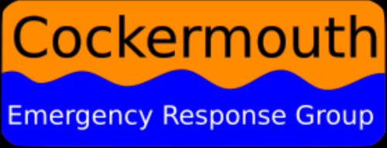

Cockermouth Emergency Response Group has been created in response to the frequent flooding of the town. The group has been created by Churches Together, Rotary and Cockermouth Flood Action Group, and is supported by the town, borough and county councils. The aim of the group is to ensure the community is better prepared for flooding.
General Data Protection Regulations Privacy Notice
- We process your data under section 1a of the General Data Protection Regulations (GDPR). This states you (the data subject) have given consent to the processing of your personal data for one or more specific purposes.
- We collect your data when you give these to us to register either as a householder or as a volunteer. The data we retain will only be that you willingly share with us
- We will take all reasonable technical precautions to prevent the loss, misuse or alteration of your personal information. We restrict access to those who have a need to know and our staff have been trained in handling the information securely.
- You have the right to withdraw your consent at any time.
- You can access the records held in person, electronically or in writing.

- We will not share your data with any third party without your express consent. We assume that by signing up as a householder or volunteer for our purposes you agree to our sharing your data with the emergency services in the event of any incident in line with section 1e of the GDPR. This states: process is necessary for the performance of a task carried out in the public interest or in the exercise of official authority vested in the controller. For example if we pass your contact details to the emergency services if you are in an area affected by floods and they need to contact you.

- We will not transfer any of your data to third countries.

- We will check regularly that your personal data is correct, although we do ask that you update us to any changes. We will ask you to confirm that you agree to the ongoing retention of your data.

- Any breach of your data gives you the right to make a complaint with the Information Commissioner's Office (https://ico.org.uk/global/contact-us/)

Brian MItchelhill
Chair
Cockermouth Emergency Response Group

REVIEWED BY:
Name | Position | Date
Brian Mitchelhill | Chair | 01 June 2022
Jo Crozier | Administrator | 01 June 2022

